**Name: Pratik Dhanaji Mane**

**Roll no: CS7-58**

**PRN: 202401110033**

**Subject: Essentials of Data Science**

**Assignment:**

Make Up Session Assignment for Theory

**1. Take one real dataset. Find any 10 grains for the given dataset. Find solutions using pandas.**

**Data set link (Kaggle):** [**https://www.kaggle.com/datasets/shantanugarg274/sales-dataset**](https://www.kaggle.com/datasets/shantanugarg274/sales-dataset)

**Data set: Sales Dataset**

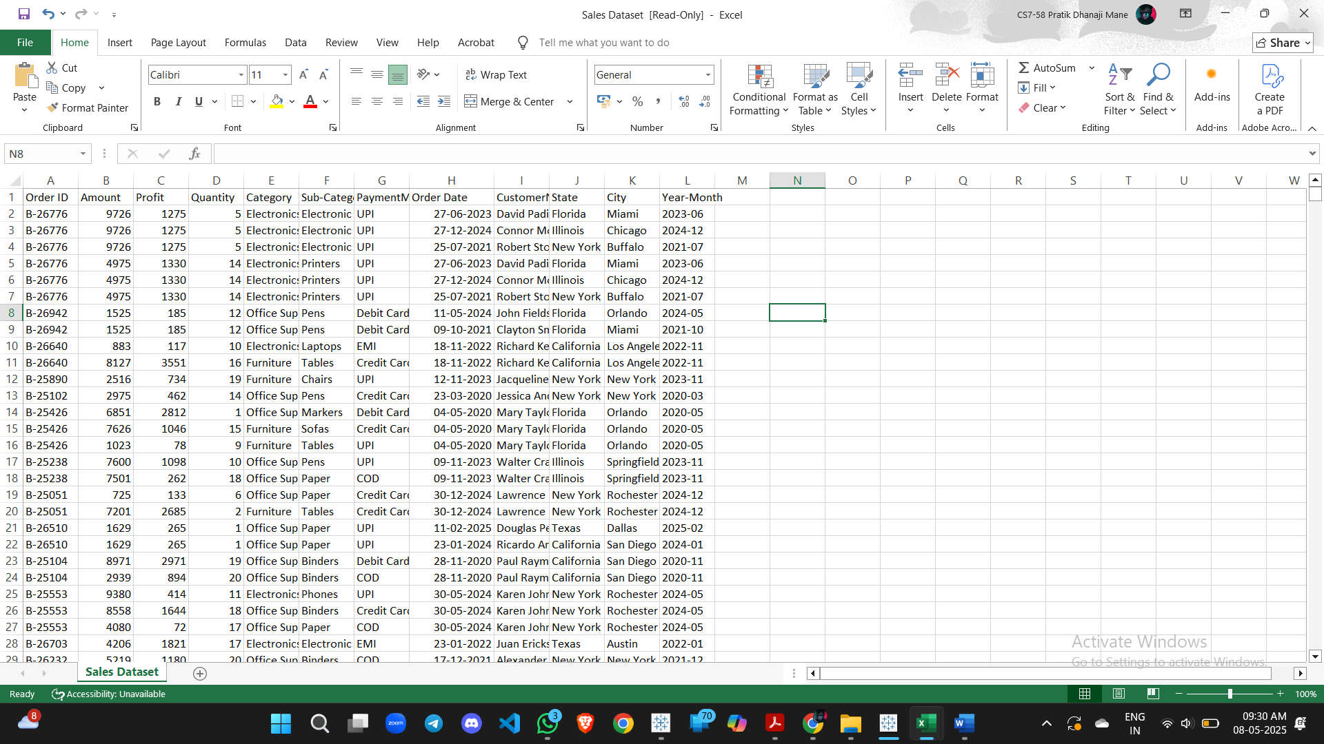

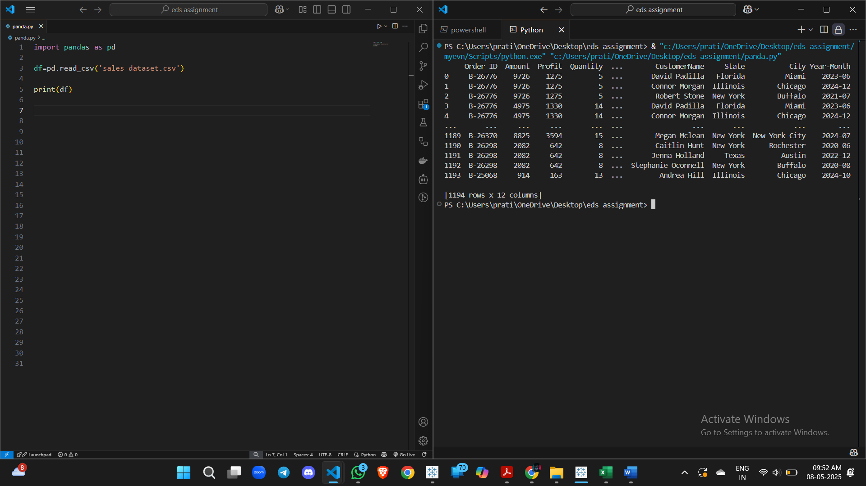

**1. Total revenue (sum of**Amount**)**

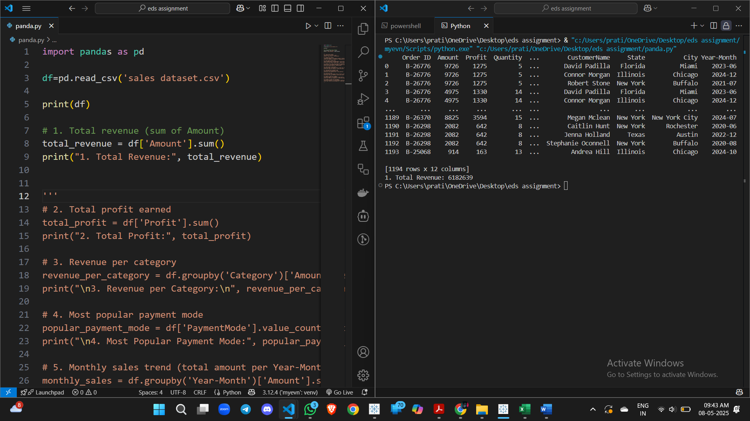

**2. Total profit earned**

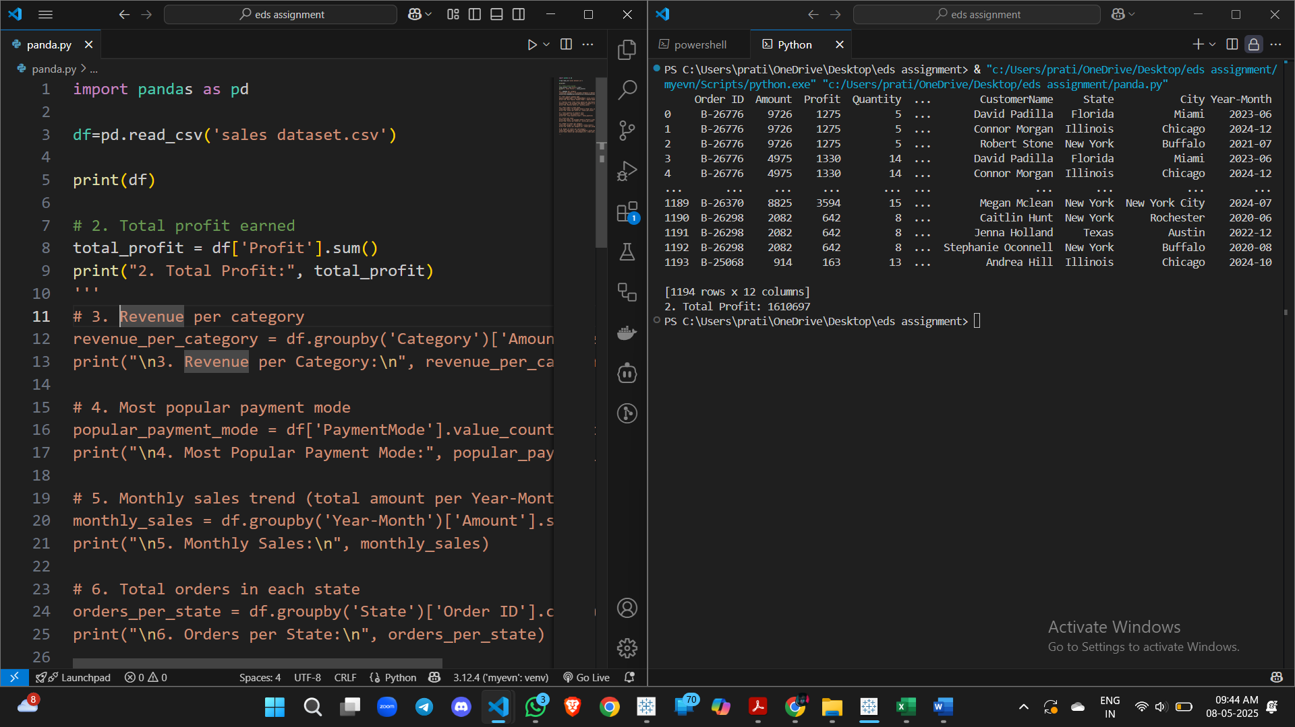

**3. Revenue per category**

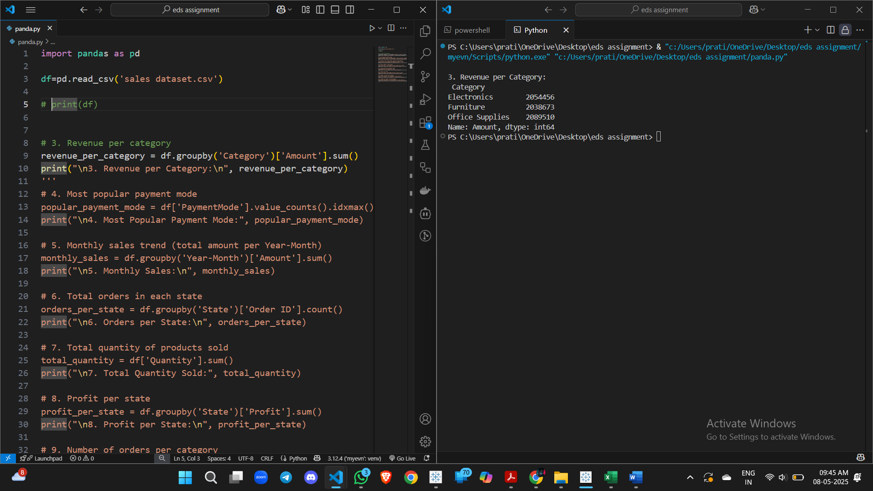

**4. Most popular payment mode**

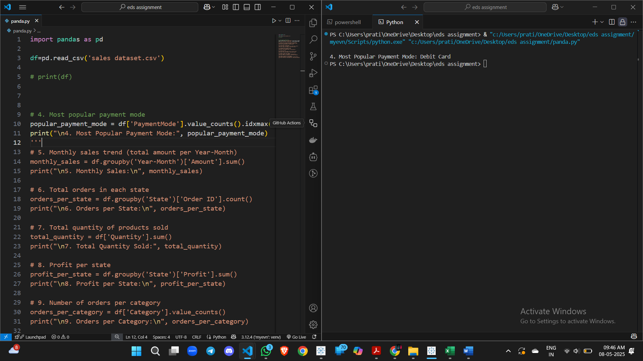

**5. Monthly sales trend (total amount per**Year-Month**)**

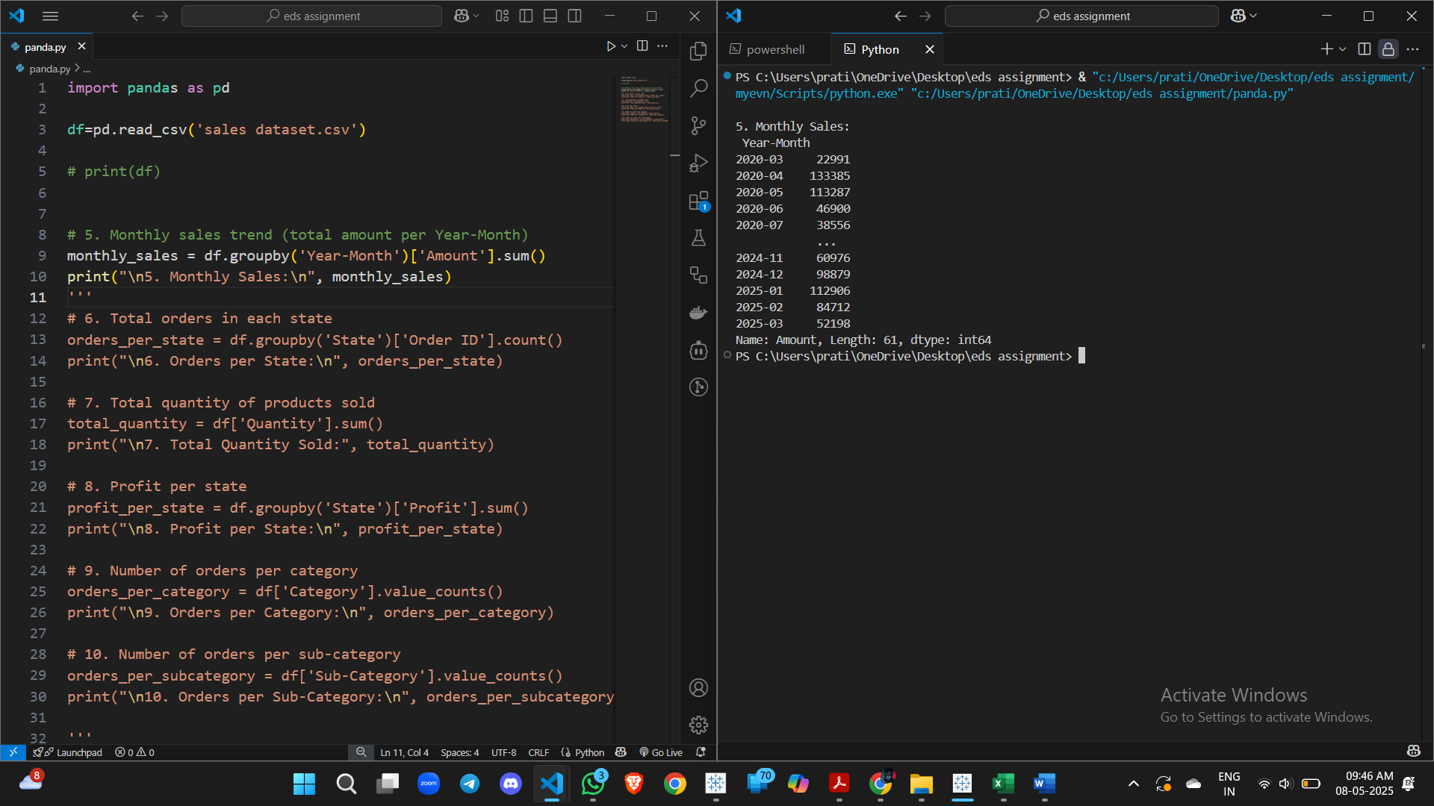

**6. Total orders in each state**

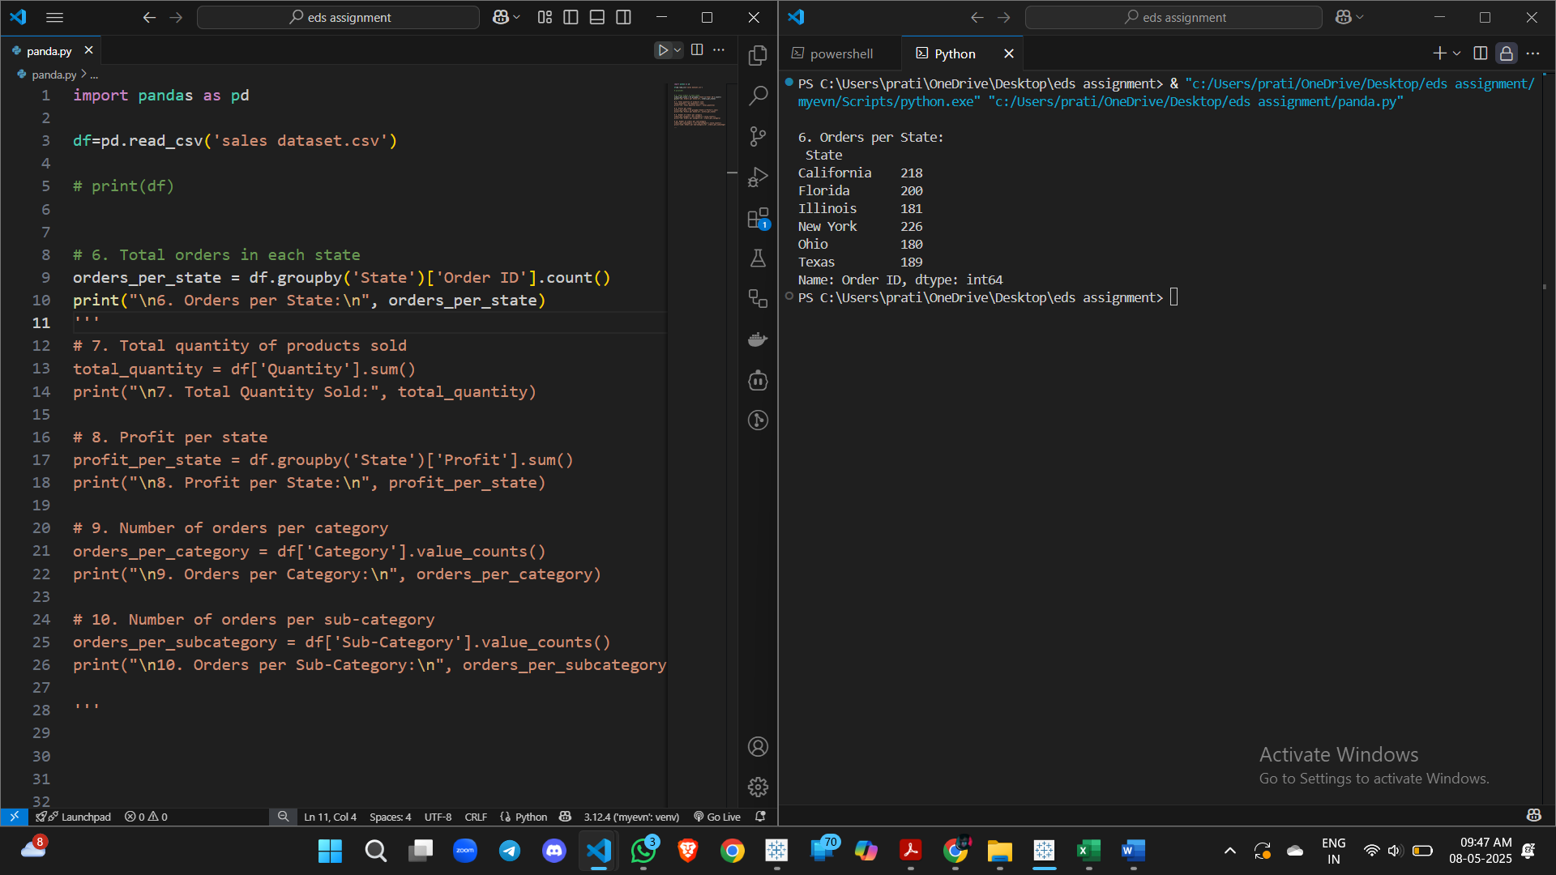

**7. Total quantity of products sold**

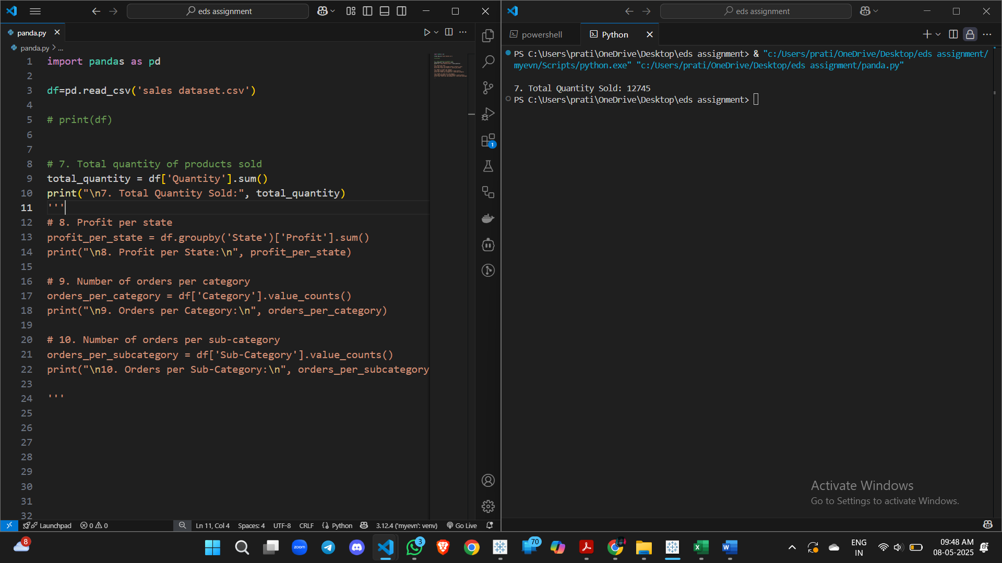

**8. Profit per state**

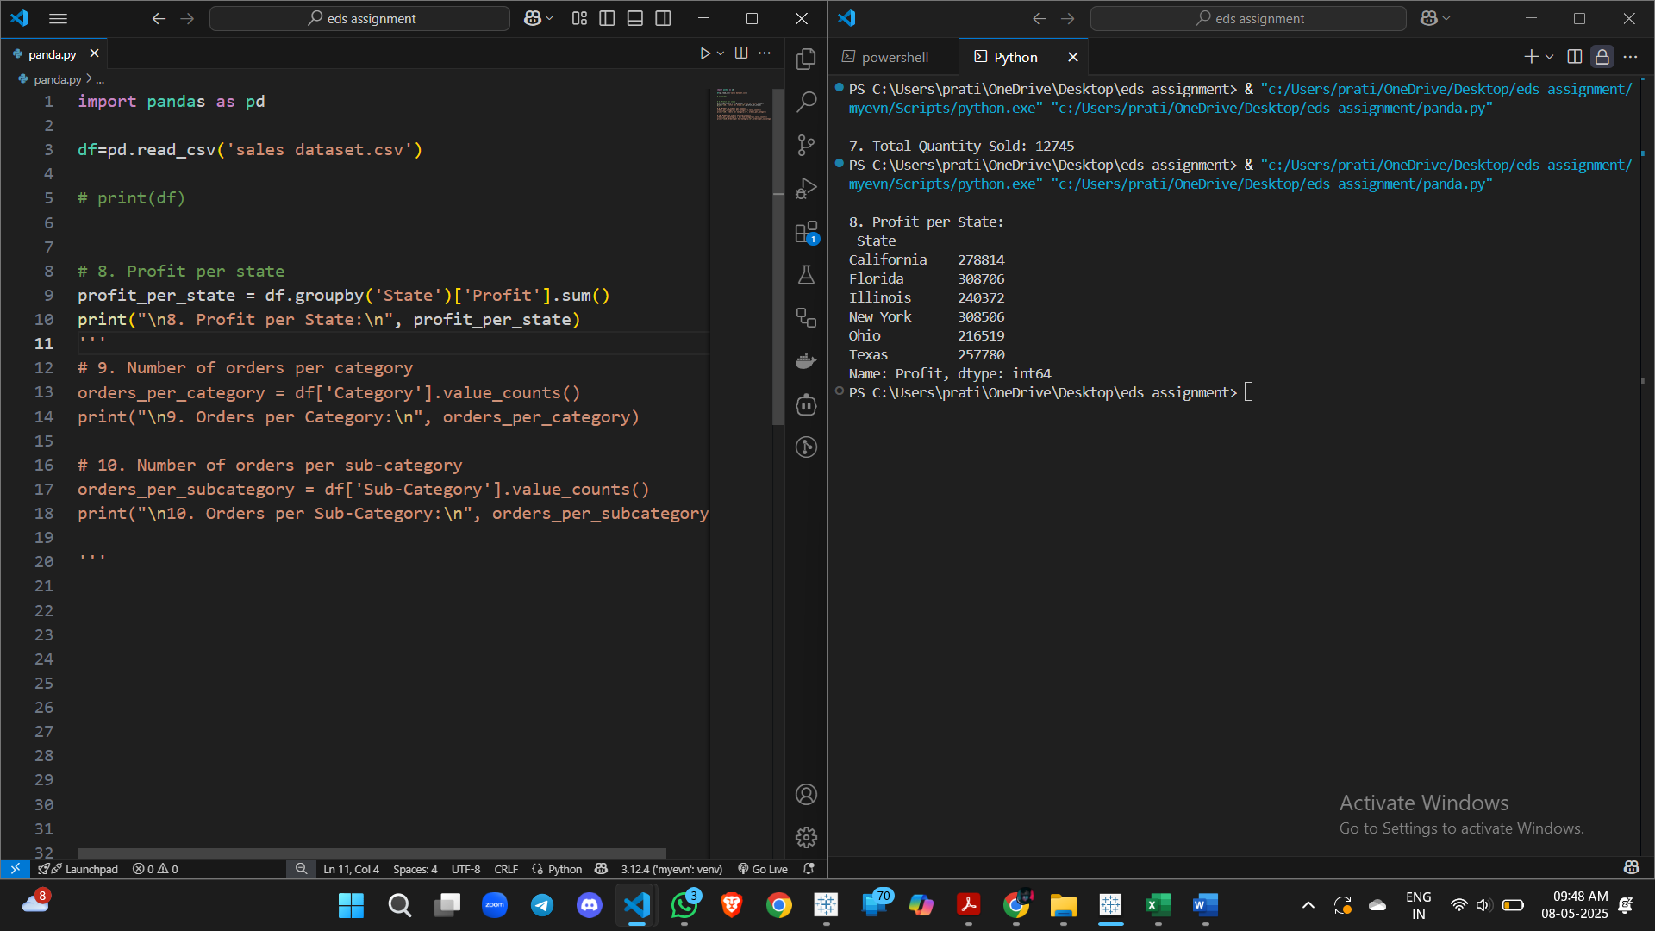

**9. Revenue per customer**

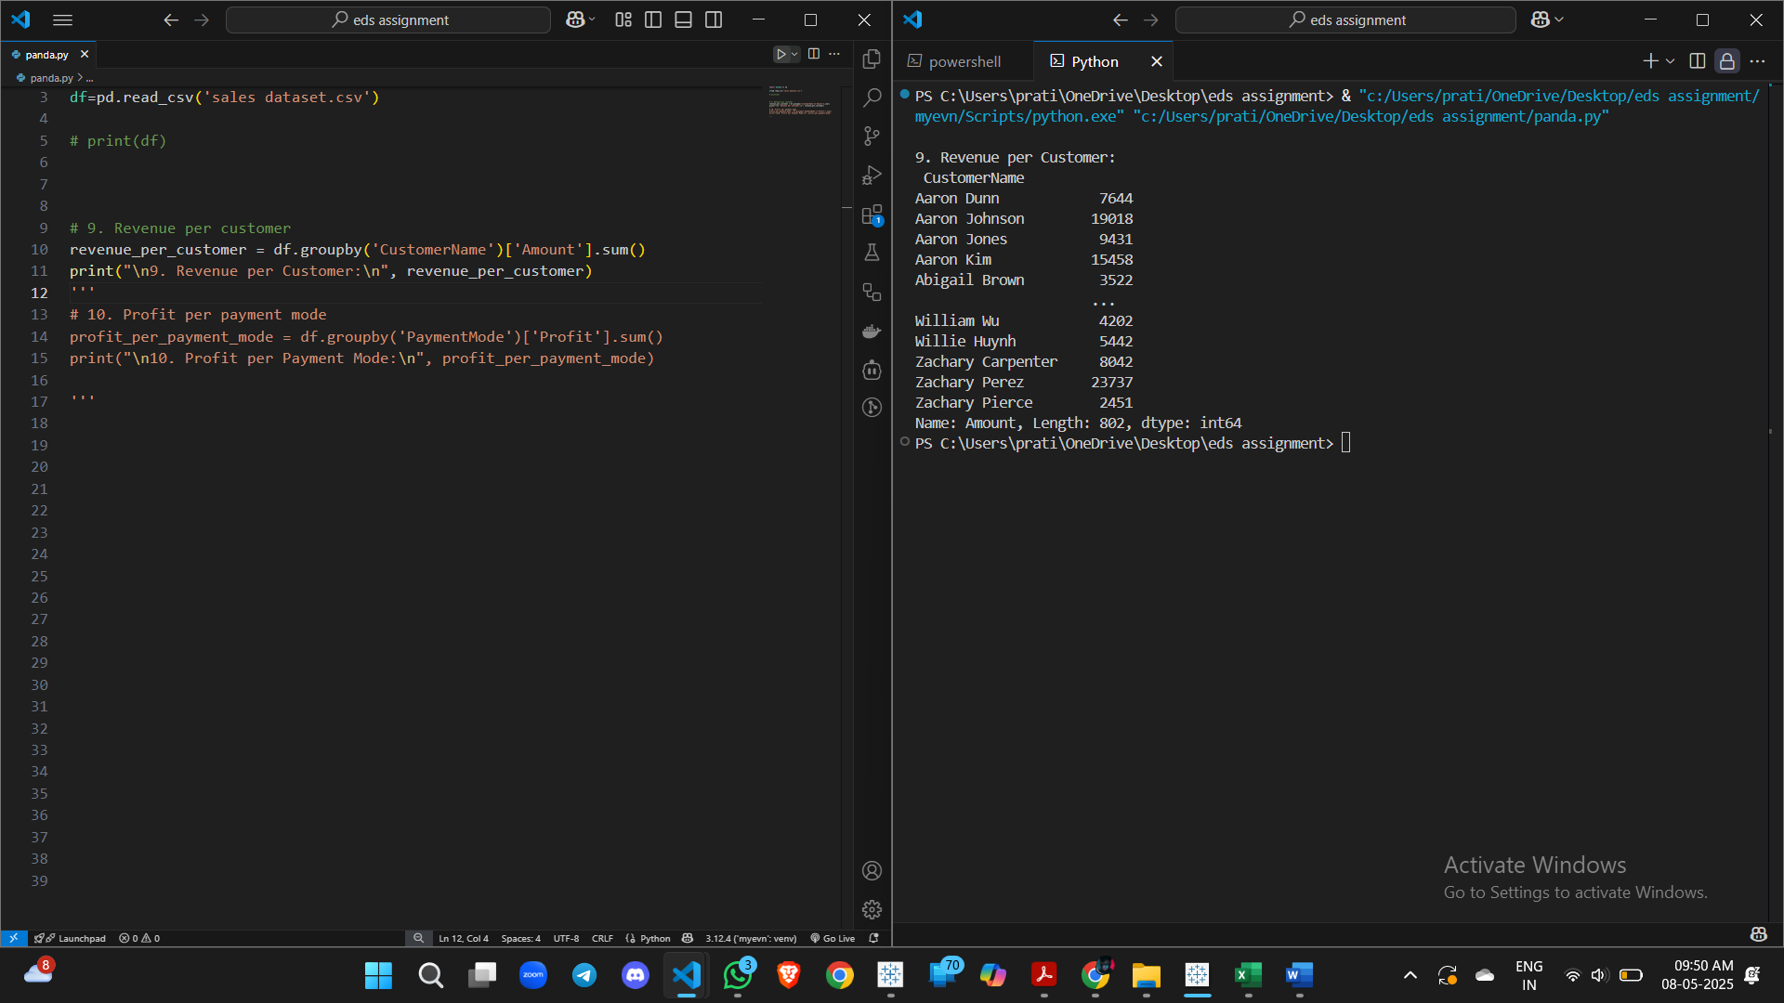

**10. Profit per payment mode**

